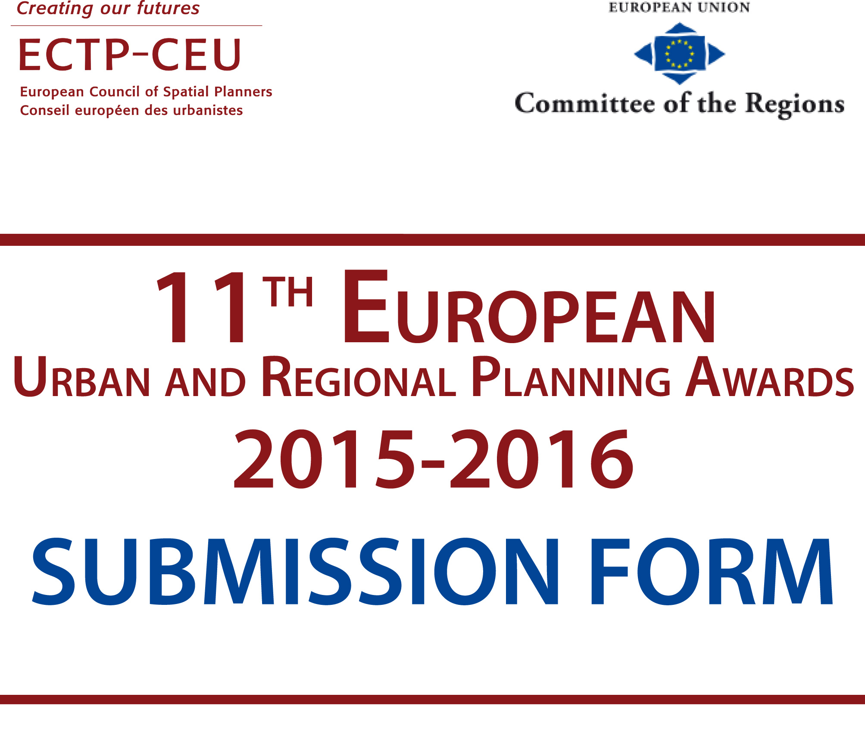


The 11th European Urban and Regional Planning Awards 2015-2016 Submission Form

The Awards are open to spatial planners and municipalities from the 47 European Countries of the Council of Europe.

Please complete this form and send it with your entry to ECTP-CEU:
Secretariat@ectp-ceu.eu

Entry Requirements:

Each entry should include:
- A detailed written description of the entry in English and in French. The description must be no longer than four A4 pages (in each language) including the title, tables and references.
- Electronic versions of two A1 colour panels, providing a clear explanation, detailed location and illustration in English. High quality print versions are required.
- All material (electronic versions of the A1 panels, written descriptions, all info) should be placed in a downloadable zip file and the web address (url) provided at submission. Sending by ‘wetransfer’ is also accepted.
- Information about any young planners (aged 37 or less) who were involved.
- The bank evidence of the entry fees.
- This Submission Form.

Deadline:

All entries must be received by March 31st 2016.

Entry Fee:

The Entry fee to the 11th European Urban and Regional Planning Awards varies depending if it is sent directly or if it is endorsed by an ECTP-CEU member (national spatial planner association).

If sent directly: 500,00 €
If endorsed by an ECTP-CEU member: 250,00 €

The endorsement by the ECTP-CEU member (national spatial planner association) can be stipulated on this form or confirmed by email exchange.

The payment should be made by bank transfer to:

Bank Name: ING Banque
Account number (IBAN): BE56 3100 0708 1288
Account name: Conseil Européen des Urbanistes
BIC code: BBRUBEBB

General Information

Please indicate the project category:
____ Strategic Planning
____ Smart mobility within cities and territories
____ Energy efficiency and spatial planning

Full title of project:
! this title will be used in all communications !

Name of Planner/s responsible for the planning input into the project:
Name of Planner/s
Company/organisation/institution/
Address
Phone/fax
E-mail

Location of the project:
Country/state/region/town
Population (if known)
Size of the area concerned (in ha):

Local authority or agency in whose name the entry is made and name of the Mayor or President of Region:
Mayor or President of Region:
Company/organisation/
institution/administration
Address
Country/state/town
Name of contact person
Phone/fax
E-mail

Degree of implementation - please insert dates as appropriate:
Project approved
Implementation started
Project completed

Please indicate the scale of the project (local - regional - interregional - national).

Extra comments (not mandatory)

Comments of the association of spatial planners from your country: (If the project is recommended by them)
Name of the association:

expert profile CV

Field | Content
Name of the expert
Photo
Areas of expertise | Highlight here the areas of expertise  - Buildings  - Environment  - Culture and Education  - Energy  - ICT and Smart Cities  - Industry and Trade  - Urban Planning  - Transport  - Water  - Waste
Golden paragraph | (short description / cv of the expert)
Contact details
Languages
Attached document
Link to external profiles
Related city

BEST PRACTICE/ Project/ PROFILE

Field | Content
Name of the project
Name of the city
Image illustrating the project
Theme category | Select out of the following 10:  Buildings  Environment  Culture and Education  Energy  ICT and Smart Cities  Industry and Trade  Urban Planning  Transport  Water  Waste
Summary information | Description of the project (150-200 words max.)
Contact person
Website link
Factual information (if applicable) | Foreseen/Available budget for this project
Factual information (if applicable) | Funding sources
Factual information (if applicable) | Duration of implementation of the best practice
Factual information (if applicable) | Impact (social, environmental, technical, etc.)  Urban perception  Mobility  Greening and public spaces  Public facilities  Environmental impact
Key words | Identify specific key words outlining the best project  Urbanism  Urban planning  Urban design  Sustainable design  Singular projects  Greening  Rehabilitation  Cultural promotion  City  Governance

