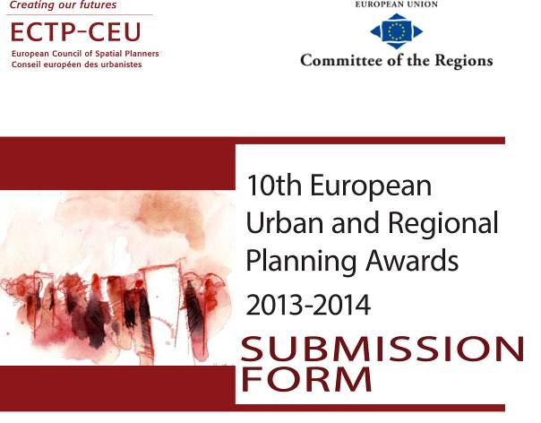


The 10th European Urban and Regional Planning Awards 2013-2014 Submission Form

Please complete this form in English and send it with your entry to your country’s ECTP-CEU member. If your country does not have an ECTP-CEU member then send it to:
ECTP-CEU : Secretariat@ectp-ceu.eu
Full title of project:

Name of Planner/s responsible for the planning input into the project:
Name of Planner/s
Company/organisation/institution/
Address
Phone/fax
E-mail

Location of the project:
Country/state/region/town
Population (if known)
Size of the area concerned (in ha):

Local authority or agency in whose name the entry is made and name of the Mayor or President of Region:
Mayor or President of Region:
Company/organisation/
institution/administration
Address
Country/state/town
Name of contact person
Phone/fax
E-mail

Degree of implementation - please insert dates as appropriate:
Project approved
Implementation started
Project completed

Please indicate the scale of the project (local - regional - interregional - national).

ECTP-CEU Organisation to which the entry will be submitted (if appropriate):

Name/acronym
Name of contact person
Phone/fax
E-mail

If the project is short-listed by the national ECTP-CEU member organisation and submitted for the final stage of judging, the ECTP-CEU member organisation should indicate why this entry should be considered an outstanding planning example worthy of recognition according to the aims of the Awards -
(Max. 500 characters)
To be completed by the national ECTP-CEU organisation only:

Entry Requirements:

Completion date: the submitted study, scheme or development must have been approved or completed before 31 January 2014.

Format: for the first stage of judging (short-listing) entries should be provided in electronic format and sent to the relevant national spatial planning organisation, or to the ECTP-CEU secretariat in Brussels.

Each entry should include:
- A detailed written description of the entry in English. (If shortlisted, a French translation will be requested). The description must be no longer than four A4 pages including the title, tables and references.

- Electronic versions of two A1 colour panels, providing a clear explanation, detailed location and illustration in English. (If shortlisted, hard copies will be requested.)

- All material (electronic versions of the A1 panels, written description, all info) should be placed in a downloadable zip file and the web address (url) provided at submission. The ECTP-CEU will request hard-copy printed A1 panels from the entrants of short-listed projects. The A1 panels will be required in hard copy once pre-selected.

- A named contact for the planners - the team or the team leader - responsible for the planning input into the selected project; a named contact for the local authority or agency which financed/commissioned the work; and the name of the chief officer (eg chief executive or mayor) and the chief planning officer.

- Information about any young planners (aged 37 or less) who were involved.

- The bank evidence of the entry fees.

- The Submission Form.

Deadline:

If you are sending your entry to your national spatial planning organisation please contact them to find out the deadline . The national spatial planning organisations must send shortlisted entries to the ECTP-CEU secretariat in Brussels by 31st January 2014.

If your country does not have a national ECTP-CEU member organisation and you are sending your entry to the ECTP-CEU secretariat for short-listing, it must arrive by 31st January 2014.

Entries that have been short-listed by a national spatial planning organisation will be forwarded to the ECTP-CEU secretariat in Brussels with an official nomination form, available on the ECTP-CEU website, including:

- A citation explaining why the entry has been short-listed and is considered worthy of European recognition (added to the entry form, where marked, by the national organisation).
- Named contacts at the national spatial planning organisation who can explain the short-listing process if required.
- Electronic versions of both the panels and the text supplied by the short-listed entries placed in a downloadable zip file and providing the download web address (url). The ECTP-CEU will request hardcopy printed A1 panels from the entrants of short-listed projects.

Entry Fee:

The Entry fee to The 10th European Urban and Regional Planning Awards is 500,00 €.

The payment should be made by bank transfer to:

Bank Name: ING Banque
Account number (IBAN): BE56 3100 0708 1288
Account name: Conseil Européen des Urbanistes
BIC code: BBRUBEBB

How to enter:

The Award is open to spatial planners and municipalities from the 47 European Countries of the Council of Europe.

There are two stages to the judging process. The first stage (short-listing) will usually be done by the ECTP-CEU member organisation in the country of each submission.

The second stage (final judging) will be done by an independent panel of judges organised by the ECTP-CEU, supported by the SPECIAL project (www.special-eu.org), in Brussels.

If your country has no ECTP-CEU member organisation you can send your entry directly to the ECTP-CEU secretariat in Brussels where it will go through an independent short-listing process. See below for more details.

National spatial planning organisations that are members of the ECTP-CEU are encouraged to nominate entries representing best practice in their country. Nominated projects can be the winners or runners-up of national award schemes, or schemes that have undergone other forms of short-listing or selection by the national organisations.

For the following countries*, entries can only be submitted by national spatial planning organisations that are members of the ECTP-CEU. Nominations from individuals are not eligible. If you would like to have a project considered you should submit it to your national selection process as early as possible.
* Belgium, Cyprus, Italy, Greece, Portugal, Spain, Germany, UK, Ireland, Norway, Slovenia, Hungary, Poland, Serbia, France, Switzerland, the Czech Republic, Estonia, Turkey, Croatia, Malta, Romania, Iceland.

In all other countries, submit entries directly to the ECTP-CEU.

Please send your entry to the ECTP-CEU secretariat in Brussels. The secretariat will arrange an independent short-listing process. The ECTP-CEU will then invite the national spatial planning organisation in your country (if there is one) to become an ‘observer’ member in order for your application to the awards scheme to be eligible.

